**Lab 1: Error Analysis and Orientation**

***Team 10***

***Joanne Doe, John Doe, Addison Smith, and Dustin Smith***

**Texas A&M University**

College Station, TX 77843, US.

***Abstract*** *This report covers the concept of velocity and acceleration vector components whilst using their properties to derive the gravitational constant. A tracking camera was used to capture the position of a puck as it accelerated down an inclined air table. The captured position at each frame was then used to calculate the velocity which was subsequently used to calculate the acceleration. Using Newton’s Second Law, the x-component of the gravitational constant was found. Finally, this value and the known angle of the table was used to calculate the magnitude of the gravitational constant. This process demonstrated the mathematical relationship between position, velocity, acceleration, and force while showing how error can present itself during such calculations.*

***Keywords:*** *Velocity, Acceleration, Newton’s Second Law, Gravitational Constant*

1. **Introduction**

The goal of this lab was to find the gravitational constant of acceleration by calibrating a tracking camera. An object needed to be dropped in order to find the gravitational acceleration where the distance at each time from the tracking camera could be found. This would allow for the calculation of the acceleration through calculations based off the change in distance and velocity over time. The data would also contain a value of uncertainty that would need to be calculated to ensure its accuracy towards the gravitational constant of acceleration.

1. **Experimental Procedure**

A personal laptop with a Linux Secure Shell Terminal (e.g. MobaXterm) and an ethernet connection was required to capture the data and the recording of the experiment. Once connected and activated, the required terminal commands, and other commands needed in order to capture and record the data acquired from the camera were inputted.

The procedure to determine the conversion between pixels (px) and SI units (cm) is as follows:

1. It was noted visually that the distance between the *center*of thetwo dots was almost exactly 29.8 cm on the ruler
2. Pink dot center at 40.8 cm along the ruler
3. Green dot center at 11 cm along the ruler
4. On the tracking camera, the (x, y) coordinates of each respective dot in px was recorded while the ruler was stationary, and the distance between the two was calculated
5. Despite the distance being in pixels, the answer was not immediately rounded
6. Because the distance between the two stickers was found in both cm and px, it was possible to compute a ratio corresponding to a quantity of pixels in a centimeter.

To capture the experiment, the plastic puck was held at the top of the incline momentarily within the camera’s view, and released – sliding down until reaching the bottom of the incline, where it was secured by another student in order to ensure it did not recoil upon impact. The disk in question always remained within the field of vision of the camera, or another trial was recorded. Recordings lasted for at least 5 seconds (~180 frames) to ensure adequate data points.

Once the requisite data was acquired, the data, recording, and all other pertinent files were saved to the personal device. The apparatus was then deactivated.

The initial data extracted from the procedure was in the form of a .csv file that listed the x- and y- coordinates of the sticker in the center of the plastic puck, including its apparent size to the camera.

1. **Results and Analysis**

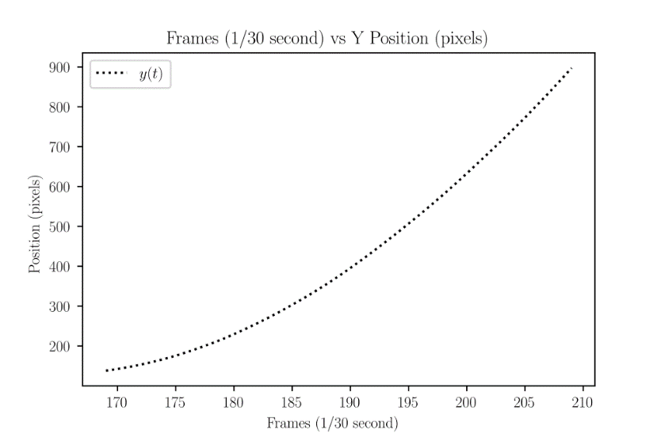

***Figure 1: Position Graph in the y Direction***

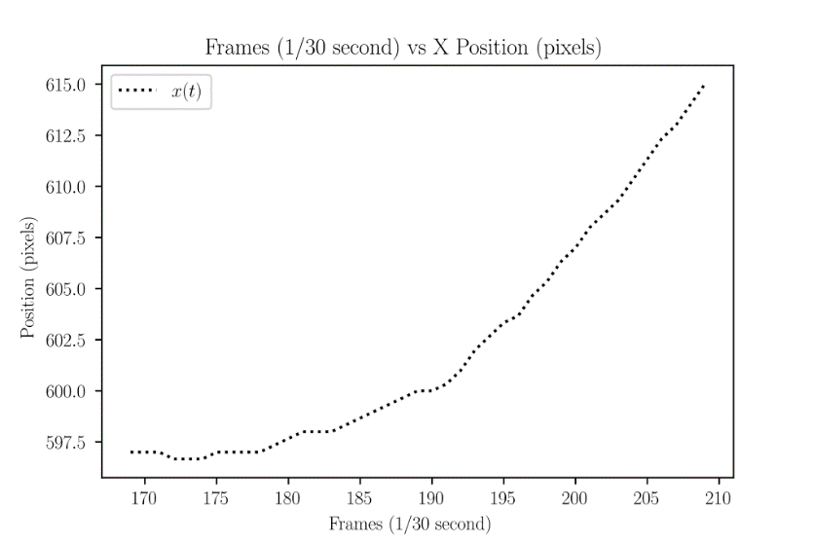

***Figure 2: Position Graph in the x Direction***

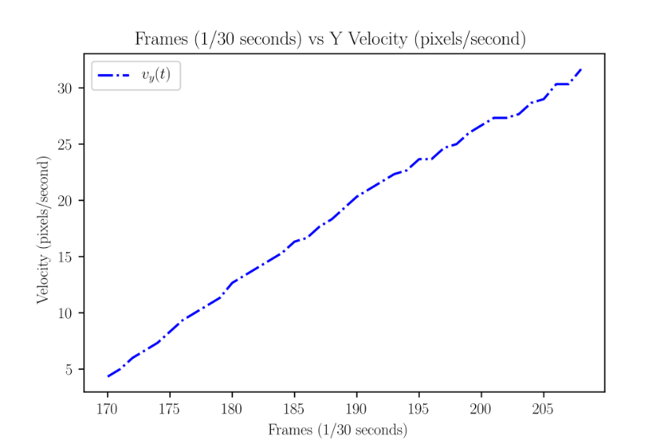

***Figure 3: Velocity Graph in the y Direction***

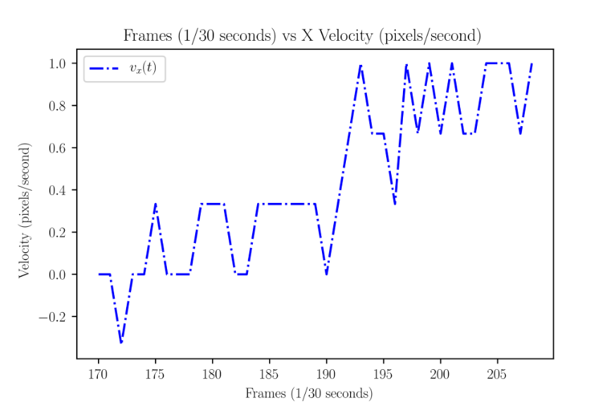

***Figure 4: Velocity Graph in the x Direction***

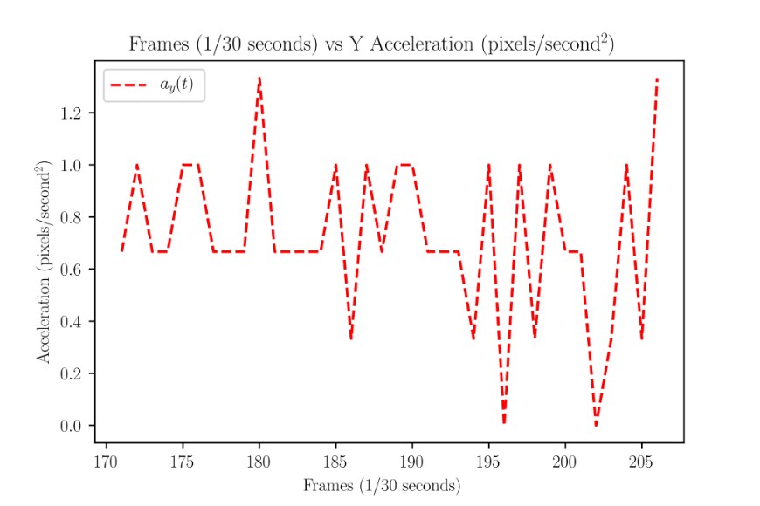

***Figure 5: Acceleration Graph in the y Direction***

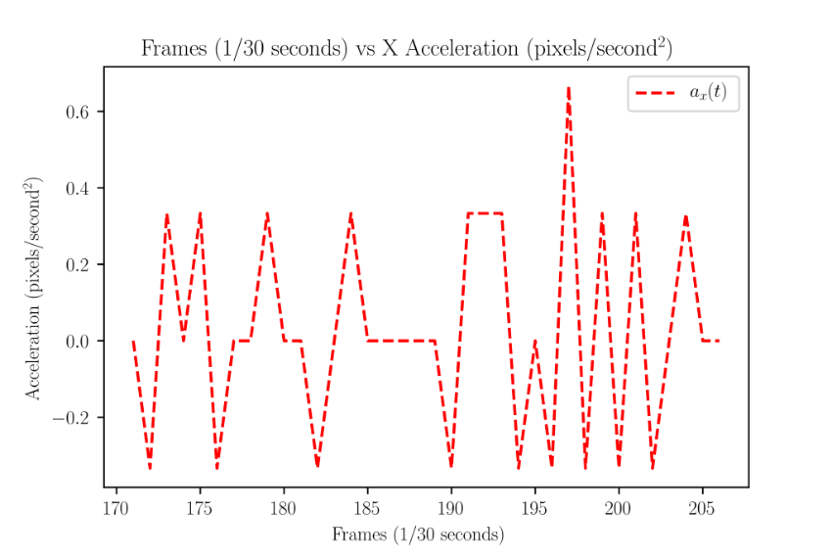

***Figure 6: Acceleration Graph in the x Direction***

1. **Conclusions**

Add here your conclusions about the work and provide a short summary of the experiments and results.

**Guidelines:**

* The length of your paper should not exceed 3 pages.
* Make sure there is an abstract, introduction, experimental procedure, results and analysis, and conclusions sections, using this template.
* Please use visual breaks (whitespace) between sections, figures, tables, etc.
* Do not change margins or font type from what is on this template.
* Use formal writing and standard language
* Avoid hand-drawing pictures and diagrams, or pictures of hand-drawn diagrams.
* Include the data used for this report in the eCampus submission as a single independent csv file.
* Figure captions should be below the figure as shown in Figure 1.
* Table captions should be placed above the table as shown in Table 1.
* Equations should be numbered to the right as shown in Equation 1 below.
* Please refer to all figures, tables, and equations in the text.
* Figures and tables are typically left justified or centered. Equations are always centered.

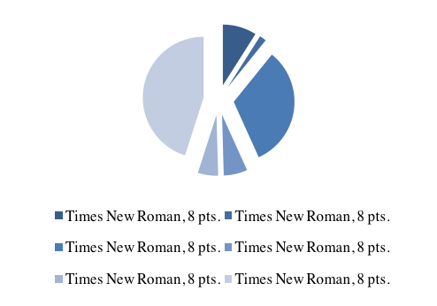

Figure 1: Description of this figure

Table 1: Description of this table

|  |  |  |
| --- | --- | --- |
| *Name of Style* | *Font Size*  *and Type* | *Use for* |
| Text | Font size in table 11 | Text |
| Text | Font size in table 11 | Text |
| Text | Font size in table 11 | Text |

Make sure equations have numbers so you can reference them in the text.

${\left(1+x\right)}^{n}=1+\frac{nx}{1!}+\frac{n\left(n-1\right)x^{2}}{2!}+…$ Equation 1

where $x$ is the quantity of interest, and $n$ is the exponent. Make sure you define each variable in the equation and the font of the variable in the text must be the same as that in the equation.

**Remove the “Guidelines” section and the example figure, table, and equation before submission.**